NANA BOATENG
SIMULATION AND COMPUTING
IMPLEMENTATION OF METROPOLIS AND SLICE ALGORITHM
1 METROPOLIS ALGORITHM
The beta(56,34) seems to be the best performing in terms of convergence to the theoritical mean of about 0.622 which is closely followed by beta(55,30).
For different starting initial values of y0=0.95,0.5 and 0.05,all three starting initial values converged closely to the theoritical mean illustrating that the initial values are not greatly significant in the implementation of the metropolis hastings algorithm.

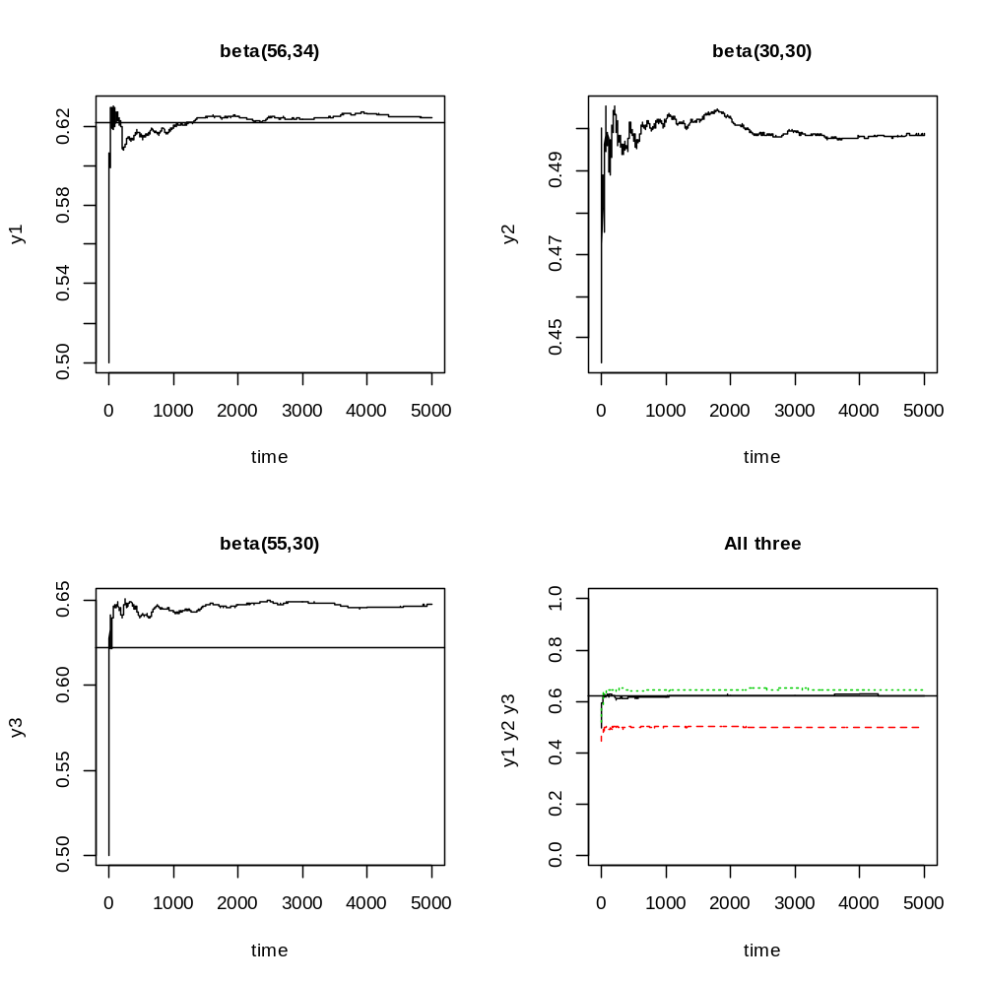

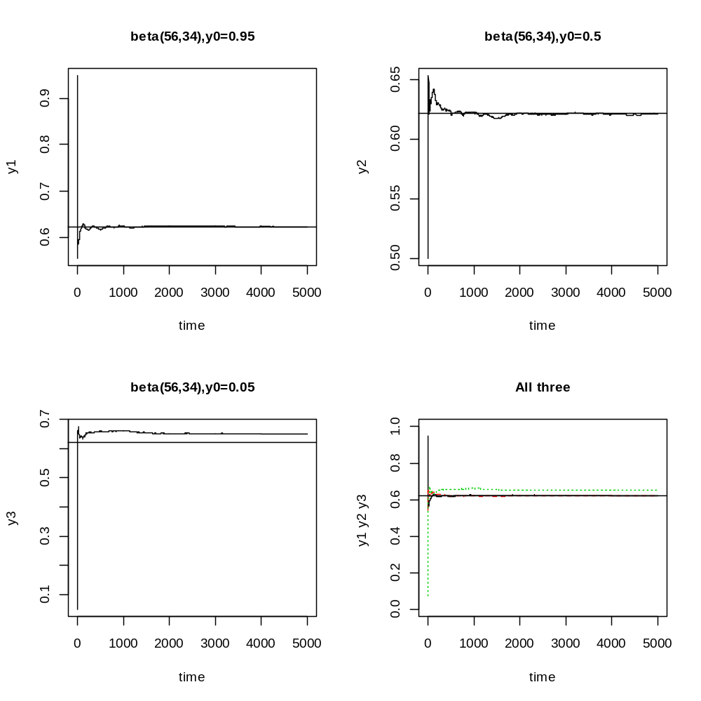

IMPLEMENTATION OF SLICE ALGORITHM
The three different initial values of theta tested were 0.95,0.5 and 0.05.The three starting points all converged to the theoritical mean of 0.622
